**Assignment - 7**

Develop a mobile application that takes the user input and sends it to IoT device (ESP32). Display the received data on the OLED display.

**Program:**

#include "BluetoothSerial.h"

#include <Wire.h>

#include <Adafruit_GFX.h>

#include <Adafruit_SSD1306.h>

#define SCREEN_WIDTH 128 // OLED display width, in pixels

#define SCREEN_HEIGHT 64 // OLED display height, in pixels

BluetoothSerial SerialBT;

Adafruit_SSD1306 display(SCREEN_WIDTH, SCREEN_HEIGHT, &Wire, -1);

void setup() {

Serial.begin(115200);

delay(3000);

Serial.println("data");

SerialBT.begin("ESP32test"); //Bluetooth device name

Serial.println("The device has started, now you can pair it with bluetooth!");

if(!display.begin(SSD1306_SWITCHCAPVCC, 0x3C)) { //0x3c

Serial.println("SSD1306 allocation failed");

for(;;);

}

delay(2000);

display.clearDisplay();//clearing the display

display.setTextSize(2); //textsize

display.setTextColor(WHITE);//color: white or blue

display.setCursor(0, 10);

display.print("Hi");

display.display();

}

void loop(){

String readString;

if (Serial.available()) {

SerialBT.write(Serial.read());

}

if (SerialBT.available()) {

Serial.write(SerialBT.read());

while (SerialBT.available()) {

delay(3);

char c = SerialBT.read();

readString+=c;

}

if (readString.length() >=0) {

Serial.println(readString);

display.clearDisplay();//clearing the display

display.setTextSize(2); //textsize

display.setTextColor(WHITE);//color: white or blue

display.setCursor(0, 10);

display.println(readString);

//Serial.write(c);

display.display();

}

}

delay(20);

}

MIT APP INVENTOR BLOCKS

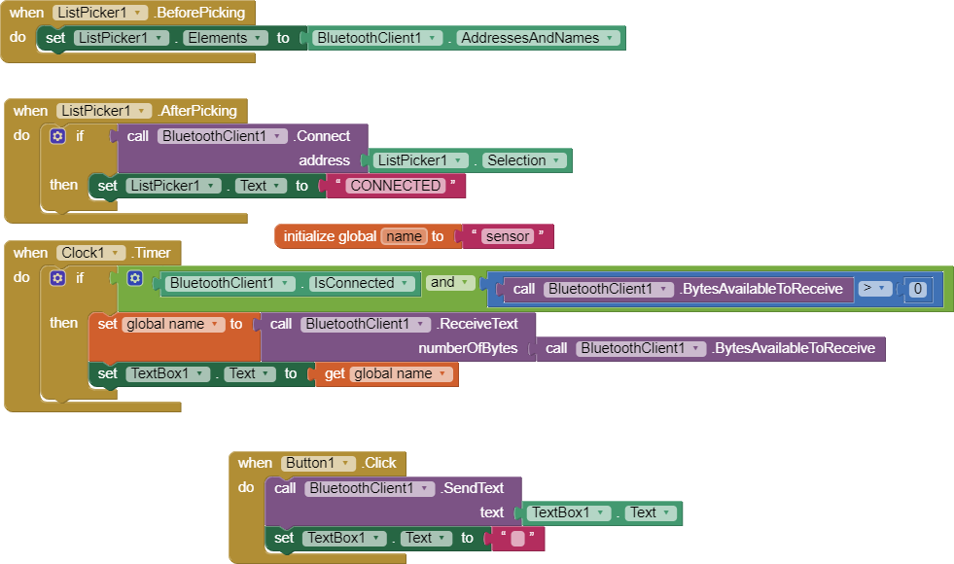

OUTPUT :

